Supplementary figures

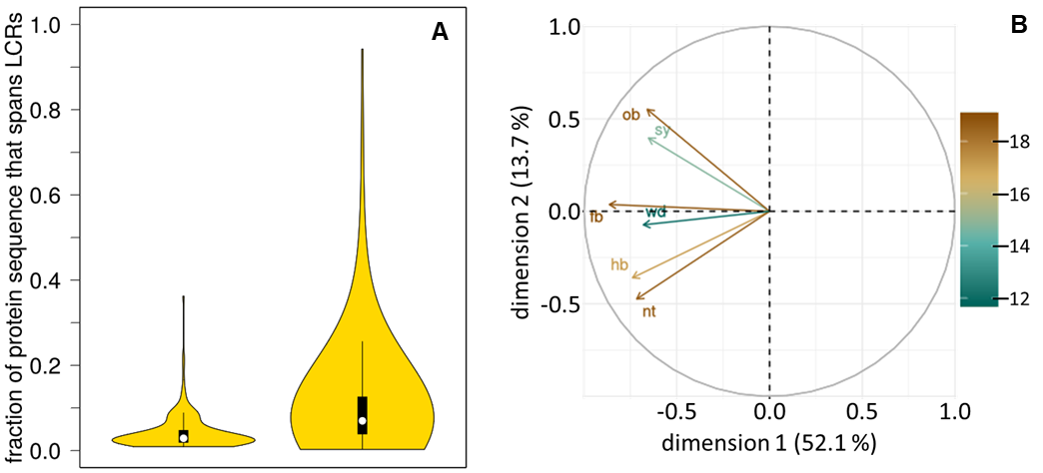

Supplementary figure 1: Fraction of secreted effector protein sequences that span a low complexity region. OrthoFinder was used to reconstruct groups of homologous proteins by natural protein sequences. Data are presented as explained in figure 3.

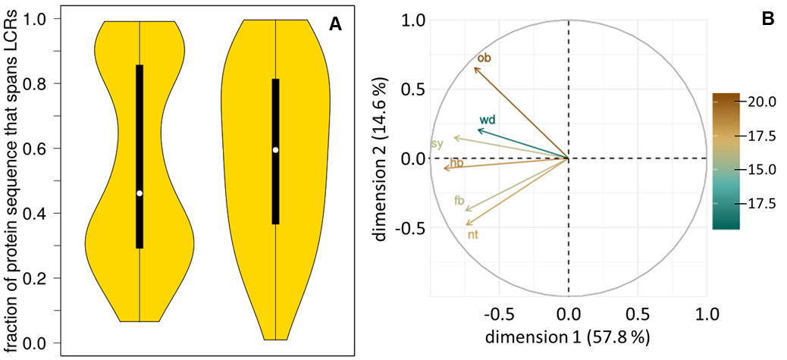
Supplementary figure 2: Relative positions of low complexity regions in effector proteins. OrthoFinder was used to reconstruct groups of homologous proteins by natural protein sequences. Data are presented as explained in figure 5.

